ESKİŞEHİR TECHNICAL UNIVERSITY

FACULTY OF ENGINEERING

Edge-Aware Temporal IDS

Buğra Muhçi
Emre Dumbo

A Bachelor of Science Project
Department of Computer Engineering

May 2026
Edge-Aware Temporal IDS

by

Buğra Muhçi
(14492562250)

Emre Dumbo
(99990935744)

Submitted in partial fulfillment of the requirements for the degree of Bachelor of Science in Computer Engineering is approved by the following scientific committee members.

Date of Approval : May 19, 2026

Member (Advisor) : Asst. Prof. Dr. Burcu YILMAZEL

Member : Prof. Dr. Serkan GÜNAL

Member : Asst. Prof. Dr. Zeynep BATMAZ

Member : Dr. Emin Talip DEMİRKIRAN

ABSTRACT

This thesis presents a real-time, edge-oriented intrusion detection system using Temporal Graph Neural Networks (TGNNs) to capture "slow-burn" cyber attacks (e.g., SSH brute-force, SQLi, XSS) that conventional static methods often fail to detect.

By transforming network traffic into dynamic temporal graphs—where network entities are modeled as nodes and time-stamped communication flows as edges—the system jointly learns structural relations and temporal behavior. The framework evaluates and compares Temporal Graph Attention Networks (TGAT), Graph Convolutional LSTM (GCLSTM), and a hybrid TGAT–GCLSTM architecture.

Trained on the large-scale LSNM2024 dataset, the pipeline integrates feature selection, SMOTE-driven class balancing, and time-windowed graph construction. While training is executed in a GPU-supported environment, the final models are deployed on a resource-constrained Raspberry Pi 5 to verify real-time operational feasibility under strict edge hardware constraints.

The resulting prototype provides a low-cost, scalable security module suitable for institutional networks. Aligned with Sustainable Development Goal 9, this open-source infrastructure offers a strong foundation for domestic cybersecurity ecosystems with high practical potential for future firewall or IDS integration.

Keywords: Temporal Graph Neural Networks, Network Intrusion Detection, Edge Computing, Cyber Attack Classification

ÖZET

Bu tez, geleneksel statik yöntemlerin tespit etmekte yetersiz kaldığı "yavaş ilerleyen" siber saldırıların (örneğin; SSH brute-force, SQLi, XSS) zamansal gelişimini yakalamak amacıyla, Zamansal Grafik Sinir Ağları (TGNN) tabanlı, gerçek zamanlı ve uç cihaz odaklı bir saldırı tespit sistemi sunmaktadır.

Ağ trafiği; ağ varlıklarının düğüm (node), zaman damgalı iletişim akışlarının ise kenar (edge) olarak modellendiği dinamik zamansal grafiklere dönüştürülerek, sistemin yapısal ilişkileri ve zamansal davranışları eş zamanlı olarak öğrenmesi sağlanmıştır. Çalışma kapsamında; Zamansal Grafik Dikkat Ağları (TGAT), Grafik Konvolüsyonel LSTM (GCLSTM) ve hibrit bir TGAT-GCLSTM mimarisi değerlendirilmiş ve karşılaştırılmıştır.

Büyük ölçekli LSNM2024 veri kümesi üzerinde yürütülen deneysel süreç; veri temizleme, öznitelik seçimi, SMOTE tabanlı sınıf dengeleme ve zaman pencereli grafik oluşturma aşamalarını içermektedir. Modellerin eğitimi GPU destekli bir ortamda gerçekleştirilirken, nihai modellerin kısıtlı kaynaklara sahip Raspberry Pi 5 uç cihazı üzerindeki gerçek zamanlı çalışma başarımı ve uygulanabilirliği test edilmiştir.

Elde edilen prototip, kurumsal ağlar için düşük maliyetli ve ölçeklenebilir bir güvenlik modülü sağlamaktadır. Sürdürülebilir Kalkınma Amacı 9 ile uyumlu olan bu açık kaynaklı altyapı, gelecekte güvenlik duvarı (firewall) veya IDS entegrasyonlarına açık ticari potansiyeliyle, Türkiye'nin yerli siber güvenlik ekosistemine güçlü bir temel sunmaktadır.

Anahtar Kelimeler: Zamansal Grafik Sinir Ağları, Ağ Saldırı Tespit Sistemi, Uç Bilişim, Siber Saldırı Sınıflandırması

ACKNOWLEDGEMENT

This work was supported by the TÜBİTAK 2209-A Research Project Support Programme for Undergraduate Students under grant number 1919B012555241.
We would like to express our sincere gratitude to our thesis advisor, Assist. Prof. Dr. Burcu Yılmazel, for her guidance, support, and valuable feedback throughout this study.
We would also like to thank GATE GROUP TEKNOLOJİ MEDYA VE SİBER GÜVENLİK HİZMETLERİ A.Ş. for their technical mentorship and industry-oriented support during the development of this project. In particular, we are grateful to Mr. Bülent Çobanoğlu, Mr. Cem Say, and Mr. Çağatay Fatih Yüksel for sharing their professional experience and providing valuable practical insights from the cybersecurity industry.
Finally, we would like to thank our families and friends for their encouragement, patience, and continuous support throughout this process.

CONTENTS

Page

ABSTRACT .................................................................................................................... i
ÖZET .............................................................................................................................. ii
ACKNOWLEDGEMENT ........................................................................................... iii
CONTENTS .................................................................................................................. iv
LIST OF FIGURES ....................................................................................................... v
LIST OF TABLES ........................................................................................................ vi
ABBREVIATIONS ...................................................................................................... vii

1. INTRODUCTION ......................................................................................................1
1.1. Background and Motivation ...................................................................... 1
1.2. Problem Statement ..................................................................................... 2
1.3. Aim and Contributions of the Study ......................................................... 3
1.4. Organization of the Thesis ......................................................................... 4

2. METHODOLOGY .................................................................................................... 5
2.1. Dataset and Preprocessing ......................................................................... 6
2.2. Temporal Graph Construction .................................................................. 9
2.3. Model Architectures ................................................................................. 10
2.3.1. Temporal Graph Attention Network ....................................... 10
2.3.2. Graph Convolutional LSTM .................................................... 11
2.3.3. Hybrid TGAT–GCLSTM Architecture ................................... 11
2.4. Training Procedure ................................................................................... 13
2.5. Experimental Testbed ............................................................................... 15
2.6. Attack Scenarios and Traffic Generation ............................................... 16
2.7. Edge Deployment and Optimization ....................................................... 18
2.8. Evaluation Metrics ................................................................................... 19
2.9. System Output and Decision Logic ......................................................... 21

3. RESULTS AND DISCUSSION .............................................................................. 23
3.1. Experimental Results ............................................................................... 23
3.2. Model Performance Comparison ............................................................ 25
3.3. Edge Deployment Results ........................................................................ 28
3.4. Discussion .................................................................................................. 30
3.5. Limitations ................................................................................................ 32
3.6 Limitations ................................................................................................. 34

4. CONCLUSIONS ...................................................................................................... 34

REFERENCES ............................................................................................................ 37
LIST OF FIGURES

Page
Figure 1. System overview. 5
Figure 2. Methodology workflow. 8
Figure 3. LSNM2024 class distribution. 3
Figure 4. Model flow. 10
Figure 5. Experimental testbed. 15
Figure 6. Overall model comparison. 25
Figure 7. Per-class F1-score comparison. 27
Figure 8. TGAT probability distribution. 28
Figure 9. GCLSTM probability distribution. 29
Figure 10. Hybrid probability distribution. 29
Figure 11. TGAT error breakdown. 30
Figure 12. GCLSTM error breakdown. 31
Figure 13. Hybrid error breakdown. 31
Figure 14. Test set class support. 33
LIST OF TABLES

Page
Table 1. Main characteristics of the LSNM2024 dataset. 7
Table 2. Comparison of the implemented temporal graph learning architectures. 12
Table 3. Training and optimization configuration. 14
Table 4. Attack scenarios considered in the experimental evaluation. 17
Table 5. Edge deployment and optimization criteria. 19
Table 6. Evaluation metrics used in the study. 21
Table 7. Overall performance comparison of models 24
Table 8. Per-class F1-score comparison of models. 26
ABBREVIATIONS

AI | Artificial Intelligence
ARP | Address Resolution Protocol
AUC | Area Under the Curve
CPU | Central Processing Unit
DDoS | Distributed Denial of Service
DGL | Deep Graph Library
DNS | Domain Name System
FTP | File Transfer Protocol
GCLSTM | Graph Convolutional Long Short-Term Memory
GNN | Graph Neural Network
GPU | Graphics Processing Unit
HTTP | Hypertext Transfer Protocol
ICMP | Internet Control Message Protocol
IDS | Intrusion Detection System
IP | Internet Protocol
LSTM | Long Short-Term Memory
LSNM2024 | Large-Scale Network Multiclass Cyberattacks Dataset 2024
MLP | Multi-Layer Perceptron
ROC | Receiver Operating Characteristic
SMOTE | Synthetic Minority Over-sampling Technique
SQL | Structured Query Language
SQLi | SQL Injection
SSH | Secure Shell
SYN | Synchronize
TCP | Transmission Control Protocol
TGAT | Temporal Graph Attention Network
TGNN | Temporal Graph Neural Network
UDP | User Datagram Protocol
XSS | Cross-Site Scripting

1. INTRODUCTION

1.1. Background and Motivation
The rapid expansion of interconnected systems, cloud services, Internet of Things devices, and edge-based network infrastructures has increased the complexity of modern cybersecurity threats. As organizational networks become larger and more distributed, cyber attacks are no longer limited to isolated malicious packets or single abnormal events. Many attacks develop gradually over time and generate behavioral patterns that can only be understood by observing traffic across multiple time intervals.
Intrusion Detection Systems (IDSs) are widely used to detect malicious activities in network traffic and to support the protection of digital infrastructures. However, the increasing scale and diversity of modern network traffic make intrusion detection a more complex engineering problem. Cyber attacks may cause financial loss, service disruption, data leakage, and operational risks for institutions. Therefore, detecting attacks at an early stage is critical for organizations such as universities, financial institutions, public networks, and enterprise infrastructures.
Traditional machine learning approaches have contributed to intrusion detection by learning discriminative patterns from flow-based or packet-based features. However, many of these methods process traffic records as independent samples. This assumption limits their ability to represent communication relationships among hosts and to capture the temporal development of attack behavior. Static deep learning models can learn complex feature representations, but they generally do not model the changing topological structure of network traffic over time [Ring, 2019; Khraisat, 2019].
This limitation is particularly important for slow-progressing attacks such as SSH brute-force, SQL Injection, XSS, port scanning, and multi-stage intrusion attempts. These attacks may not appear highly suspicious when individual packets or flows are examined separately. Their malicious nature becomes more visible when repeated communication attempts, temporal changes, and evolving relations between network entities are analyzed together. Therefore, intrusion detection requires not only feature-based classification, but also time-aware and structure-aware modeling.

1.2. Problem Statement
Recent studies show that Graph Neural Networks (GNNs) provide a useful framework for modeling relational data because they can represent entities and their interactions as graph structures [Kipf, 2016; Ibrahim, 2025]. In network security, graph-based representations allow an IDS to learn how hosts, services, and communication flows interact with each other instead of analyzing every connection as a separate record. This makes GNNs suitable for modeling the structural characteristics of network traffic.
However, many graph-based intrusion detection approaches still rely on static graph representations, where network traffic is modeled as a fixed snapshot. This is a significant limitation because both normal traffic behavior and attack behavior evolve over time. A static graph may represent which entities communicated, but it does not sufficiently capture when the communication occurred, how frequently it was repeated, or how the pattern changed across consecutive time windows.
Temporal Graph Neural Networks (TGNNs) address this limitation by incorporating time into graph-based learning. Models such as Temporal Graph Attention Network (TGAT) and graph recurrent architectures can learn from time-stamped interactions and graph sequences [Xu, 2020; Rossi, 2020; Sankar, 2020]. TGAT uses temporal attention and time encoding to capture time-aware neighborhood relations, while Graph Convolutional LSTM (GCLSTM) combines graph convolution with recurrent memory to process sequential graph snapshots [Xu, 2020; Seo, 2018; Pareja, 2020].
Although TGNNs have been applied in domains such as recommender systems, social networks, and financial analysis, their use in intrusion detection remains relatively limited. Another important research gap is the deployment of these models on resource-constrained edge devices. Many AI-based intrusion detection solutions depend on server-side or cloud-based infrastructures, which may increase latency, cost, and dependency on centralized systems. For institutional networks, university campuses, banking infrastructures, and distributed edge environments, lightweight and locally deployable security modules are needed.
This thesis addresses this problem by developing and evaluating an edge-aware temporal intrusion detection system. The system models network traffic as a temporal graph and analyzes it through TGAT, GCLSTM, and a hybrid TGAT–GCLSTM architecture. In this way, the study focuses on both the detection of temporal attack behavior and the feasibility of deploying graph-based intrusion detection on low-cost edge hardware.

1.3. Aim and Contributions of the Study
The main aim of this thesis is to design and evaluate a Temporal Graph Neural Network based intrusion detection system that can identify cyber attacks in network traffic while remaining suitable for edge-device deployment. The study focuses on both detection performance and practical deployment feasibility.
The main contributions of this thesis are as follows:
- Network traffic is represented as a sequence of temporal graphs, allowing the system to learn both structural dependencies between network entities and temporal changes in traffic behavior.
- TGAT, GCLSTM, and hybrid TGAT–GCLSTM architectures are examined for multiclass cyber attack detection using the LSNM2024 dataset.
- Class imbalance is addressed through preprocessing and learning strategies such as SMOTE and class-weighted loss functions [Chawla, 2002].
- The system is evaluated not only through classification metrics such as accuracy, macro-F1 score, precision, recall, and ROC-AUC, but also through edge-oriented deployment criteria such as inference latency, throughput, and memory usage.
- Raspberry Pi 5 is used as the target edge platform to analyze the feasibility of running an intelligent intrusion detection module on low-cost hardware.
- The study provides a prototype basis for future integration with firewall or IDS platforms such as pfSense and Suricata, supporting the development of scalable and locally deployable cybersecurity solutions.
In this respect, the thesis contributes to the intersection of graph-based machine learning, cyber attack detection, and edge computing. It also supports broader technological goals related to domestic cybersecurity infrastructure, AI-based security systems, and Sustainable Development Goal 9, which emphasizes industry, innovation, and infrastructure.
A high-level view of the proposed edge-aware temporal intrusion detection approach is shown in Figure 1. The system first transforms network traffic into temporal graph representations, then processes these graph sequences through TGAT, GCLSTM, and hybrid TGAT–GCLSTM models. The final predictions are used as the basis for an edge-deployable intrusion detection module running on Raspberry Pi 5.
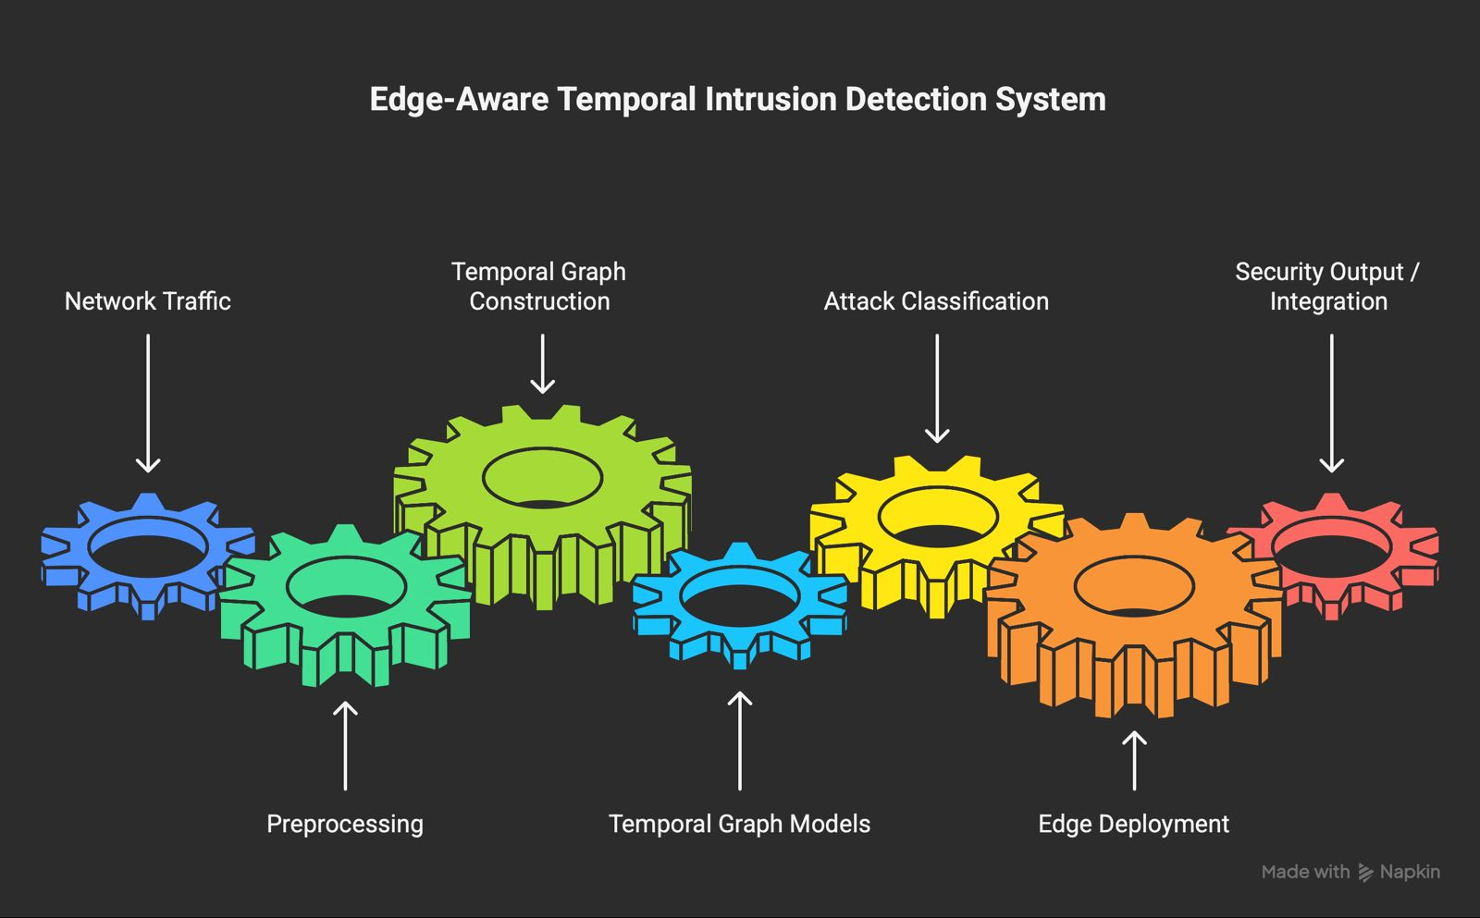
Figure 1. High-level overview of the proposed edge-aware temporal intrusion detection system.

1.4. Organization of the Thesis
The remainder of this thesis is organized into three main chapters. Chapter 2 describes the methodology followed in the study, including the dataset, preprocessing steps, temporal graph construction, model architectures, training procedure, experimental testbed, and edge-device deployment strategy. Chapter 3 presents the experimental results and discusses the performance of the implemented models in terms of classification accuracy, macro-F1 score, precision, recall, ROC-AUC, inference latency, throughput, and memory usage. This chapter also compares the behavior of TGAT, GCLSTM, and the hybrid TGAT–GCLSTM architecture and discusses the limitations observed during the experiments. Finally, Chapter 4 concludes the thesis by summarizing the main findings, highlighting the contributions of the study, and presenting possible directions for future work.

2. METHODOLOGY
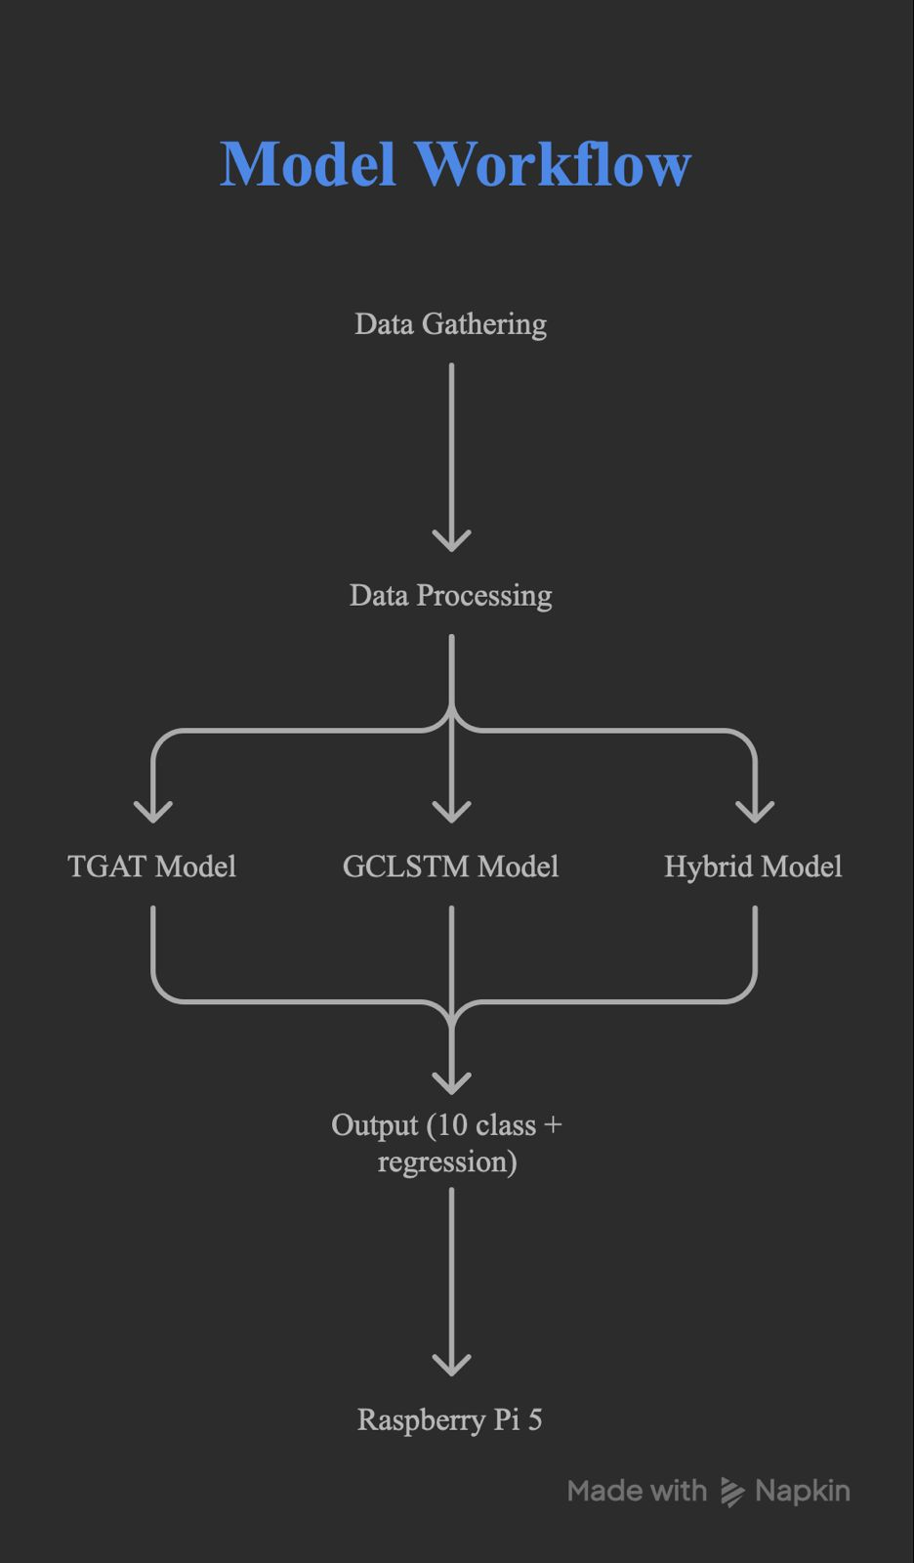
This chapter presents the methodological framework followed in the design, implementation, and evaluation of the proposed edge-aware temporal intrusion detection system. The study was organized as a complete pipeline consisting of dataset preparation, temporal graph construction, model development, training, evaluation, and edge-device deployment. The overall workflow of the system is shown in Figure 2.
Figure 2. General workflow of the proposed edge-aware temporal intrusion detection system.
The methodology was designed to overcome the limitations of conventional intrusion detection approaches that process network traffic either as independent flow records or as static snapshots. In contrast, this study modeled network traffic as a sequence of temporal graphs. This representation enabled the system to learn both the structural relations among network entities and the temporal evolution of attack behavior. The main model architectures examined in the study were Temporal Graph Attention Network (TGAT), Graph Convolutional Long Short-Term Memory (GCLSTM), and a hybrid TGAT–GCLSTM architecture. TGAT was used to capture time-aware interactions through temporal attention, while GCLSTM was used to process graph snapshots sequentially through recurrent graph learning [Xu, 2020; Seo, 2018; Pareja, 2020].

2.1. Dataset and Preprocessing
The experimental process was based on the LSNM2024 dataset, a large-scale multiclass network intrusion dataset containing timestamped traffic records and multiple attack categories [Al-Haija, 2024a; Al-Haija, 2024b; Al-Haija, 2025]. The dataset includes both benign and malicious traffic, with attack categories such as SSH brute-force, FTP brute-force, DDoS, SQL Injection, XSS, SYN flood, port scanning, fuzzing, remote code execution, and ARP spoofing. Since the dataset contains timestamped flow-level and packet-level attributes, it is suitable for both temporal modeling and graph-based intrusion detection.
The main characteristics of the dataset are summarized in Table 1.

Table 1. Main characteristics of the LSNM2024 dataset.
Property | Description
Dataset | LSNM2024
Data type | Timestamped network traffic records
Task | Multiclass intrusion detection
Classes | Normal traffic and multiple attack categories
Example attacks | SSH brute-force, FTP brute-force, DDoS, SQL Injection, XSS, SYN flood, port scanning, ARP spoofing
Main feature groups | Source/destination information, protocol fields, packet statistics, TCP flags, DNS/HTTP-related fields
Main challenge | Class imbalance among attack categories

Before model training, the dataset was processed through a structured preprocessing pipeline. First, irrelevant, incomplete, and non-informative fields were removed. Categorical attributes such as protocol type and TCP flag information were encoded into numerical form. Numerical features such as packet length, flow duration, connection frequency, and protocol-based counters were normalized to reduce scale differences among input variables. Timestamp information was preserved because the temporal order of events was essential for time-window generation and dynamic graph construction.
A major issue in the dataset was the imbalance among attack classes. Some attack categories appeared much less frequently than high-volume attack classes. To reduce the effect of this imbalance, two complementary strategies were used. First, the Synthetic Minority Over-sampling Technique (SMOTE) was applied to underrepresented attack classes [Chawla, 2002]. Second, class-weighted loss functions were used during training so that minority classes had a stronger effect on the optimization process. This design reduced the tendency of the models to favor dominant classes and improved the reliability of macro-level evaluation.
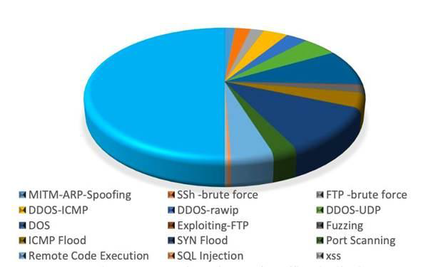
The class distribution of the dataset is illustrated in Figure 3.
Figure 3. Distribution of normal and attack traffic classes in the LSNM2024 dataset.
At the end of the preprocessing stage, the dataset was transformed into cleaned, normalized, timestamp-preserving traffic records. These records were then used as the input for temporal graph construction.

2.2. Temporal Graph Construction
After preprocessing, the network traffic records were transformed into temporal graph sequences. In this representation, network entities were modeled as nodes and communication flows were modeled as edges. Depending on the selected granularity, nodes represented either IP addresses or IP:port pairs. Edges represented timestamped communication events between these entities.
The traffic records were divided into fixed-length time windows. Each time window generated one graph snapshot containing all network events observed within that interval. This approach made it possible to analyze how the network structure changed over time instead of evaluating each flow as a separate sample. Different window sizes, such as 1 second, 5 seconds, and 30 seconds, were considered to examine the effect of temporal granularity on detection performance.
For each graph snapshot, node-level and edge-level features were extracted. Node features included total packet count, average packet size, protocol distribution, and inter-arrival time statistics. Edge features included flow direction, connection frequency, payload-related ratios, SYN/ACK behavior, and communication-specific indicators. These features allowed the models to learn both local node behavior and interaction patterns between network entities.
The generated graph sequence is represented as:
G = \{G_1, G_2, ..., G_T\}
where each G_t denotes the graph snapshot generated for time window t. Each snapshot is defined as:
G_t = (V_t, E_t, X_t, A_t)
where V_t is the node set, E_t is the edge set, X_t represents node and edge features, and A_t denotes the adjacency structure of the graph at time t. This formulation enabled the system to learn dynamic attack behavior from consecutive graph states.

2.3. Model Architectures
Three temporal graph learning architectures were implemented and compared: TGAT, GCLSTM, and a hybrid TGAT–GCLSTM model. The purpose of this comparison was to evaluate whether attention-based temporal modeling, recurrent graph-based modeling, or a combined architecture was more effective for edge-oriented intrusion detection.
The overall model pipeline is shown in Figure 4.
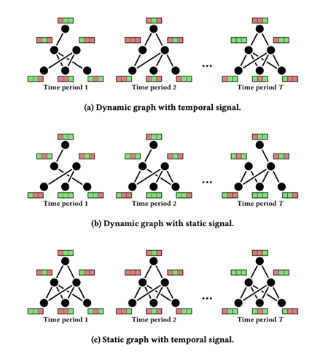
Figure 4. Model flow of the proposed temporal graph-based intrusion detection system.

2.3.1. Temporal Graph Attention Network
TGAT was used to capture time-dependent interactions between network entities. Unlike static graph neural networks, TGAT includes temporal information within the attention mechanism. This allows the model to assign importance to neighboring nodes and edges not only according to graph topology but also according to event time. Time encoding was used to represent the temporal distance between network events [Xu, 2020; Dai, 2024].
This mechanism is important for intrusion detection because attacks such as brute-force attempts, port scanning, and slow HTTP-based attacks often appear as repeated or gradually evolving patterns rather than isolated events. TGAT enabled the system to learn whether a traffic pattern was an independent connection or part of a larger temporal attack sequence.

2.3.2. Graph Convolutional LSTM
GCLSTM was used to process sequential graph snapshots. In this architecture, graph convolution operations capture the spatial structure of each graph snapshot, while LSTM units preserve temporal information across consecutive windows [Seo, 2018; Pareja, 2020]. This made GCLSTM suitable for modeling attacks that develop across multiple time intervals.
For each time window, the corresponding graph representation was passed through graph convolutional layers. The resulting hidden state was then transferred to the next time step through recurrent memory. In this way, the model preserved information from previous graph states and used it when classifying later traffic behavior.

2.3.3. Hybrid TGAT–GCLSTM Architecture
The hybrid TGAT–GCLSTM architecture was developed to combine the strengths of attention-based and recurrent temporal graph learning. TGAT contributed event-level temporal attention and neighborhood weighting, while GCLSTM contributed sequential memory across graph snapshots. Therefore, the hybrid model was designed to capture both short-term temporal interactions and longer-term attack progression.
In the hybrid pipeline, temporal graph embeddings produced by the TGAT component were transferred to the GCLSTM component for sequential processing. The final temporal representation was then passed to a Multi-Layer Perceptron classifier. The classifier generated class probabilities using a Softmax output layer and produced the final multiclass attack prediction.
A compact comparison of the three implemented architectures is given in Table 2.

Table 2. Comparison of the implemented temporal graph learning architectures.
Model | Main mechanism | Strength | Role in this study
TGAT | Temporal attention and time encoding | Captures time-aware neighborhood relations | Detects short-term temporal attack patterns
GCLSTM | Graph convolution and recurrent memory | Models sequential graph snapshots | Detects longer temporal dependencies
Hybrid TGAT–GCLSTM | Attention-based embeddings followed by recurrent graph processing | Combines short-term and long-term temporal learning | Provides the main comparative architecture

2.4. Training Procedure
The models were implemented in a Python-based deep learning environment using PyTorch and graph-learning libraries such as PyTorch Geometric or DGL. Training was performed in a GPU-supported environment to reduce computation time and to ensure that all models were evaluated under comparable experimental conditions.
The dataset was divided into training, validation, and test subsets. Since the order of events is important in network traffic analysis, temporal hold-out validation was used to preserve chronological consistency. Stratified validation was also considered to maintain class distribution across subsets. TGAT, GCLSTM, and the hybrid model were trained independently using the same preprocessing steps, graph construction strategy, and evaluation criteria.
The main optimization algorithm was AdamW. Cross-entropy loss was used as the primary loss function, and class-weighted cross-entropy was applied to reduce the effect of class imbalance. In cases where minority-class detection required additional adjustment, focal-loss-based training was considered. Hyperparameters such as hidden dimension, learning rate, number of layers, dropout rate, sequence length, and number of attention heads were tuned experimentally.
The main training configuration is summarized in Table 3.

Table 3. Training and optimization configuration.
Component | Configuration
Framework | PyTorch / PyTorch Geometric or DGL
Optimizer | AdamW
Loss function | Cross-entropy and class-weighted cross-entropy
Imbalance handling | SMOTE and class weighting
Validation strategy | Temporal hold-out and stratified validation
Main metric | Macro-F1 score
Additional metrics | Accuracy, precision, recall, ROC-AUC
Tuned parameters | Learning rate, hidden size, dropout, sequence length, attention heads

Macro-F1 score was selected as the primary performance criterion because the dataset contains imbalanced attack classes. Accuracy was also reported, but it was not treated as the only indicator of success because high accuracy may be misleading when majority classes dominate the dataset. Precision, recall, and ROC-AUC were used to provide a more complete assessment of classification behavior.

2.5. Experimental Testbed
The deployment-oriented part of the study was carried out through an isolated laboratory testbed. The testbed consisted of a Raspberry Pi 5, a victim machine, an attacker machine, and a management workstation. The Raspberry Pi 5 was used as the target edge device for inference tests. The management workstation was used for model training, preprocessing, hyperparameter tuning, and performance analysis.
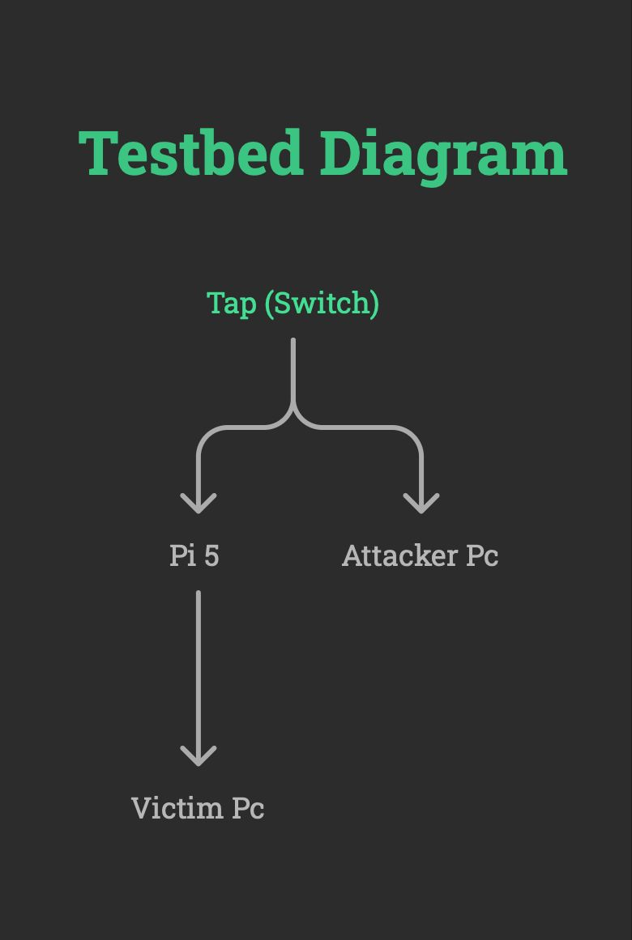
The experimental testbed is presented in Figure 5.
Figure 5. Isolated laboratory testbed used for edge-device inference and attack-scenario evaluation.
Raspberry Pi 5 was selected because it represents a low-cost and resource-constrained edge platform. This enabled the study to evaluate whether temporal graph neural network models could operate outside server-side or cloud-based environments. In the testbed setup, the Raspberry Pi was positioned either as a passive monitoring device or as an inline proxy/firewall-like component. Network traffic was transferred to the device through port mirroring or a similar controlled traffic-forwarding mechanism.
The testbed was isolated from production networks for safety, repeatability, and ethical compliance. Attack scenarios were executed only under controlled laboratory conditions. The purpose of this environment was not to attack real systems, but to evaluate whether the trained intrusion detection model could process traffic and generate meaningful predictions under realistic edge-device constraints.

2.6. Attack Scenarios and Traffic Generation
Several attack scenarios were considered to evaluate the robustness of the system. These scenarios included SSH brute-force, FTP brute-force, SYN flood, UDP flood, ICMP-based DDoS, port scanning, SQL Injection, XSS, Slowloris or slow HTTP behavior, and command-and-control-like callback patterns. These scenarios were selected because they represent both high-volume attacks and slow-progressing threats that require temporal context for reliable detection.
Each attack scenario was parameterized using variables such as packet rate, attack duration, target IP address, target port, and protocol type. This allowed controlled repetition of experiments and made it possible to compare model behavior under different traffic intensities. Both individual attack scenarios and mixed attack conditions were used to test whether the models could distinguish between similar traffic behaviors.
The attack-scenario design is summarized in Table 4.

Table 4. Attack scenarios considered in the experimental evaluation.
Scenario | Example behavior | Purpose
SSH brute-force | Repeated login attempts | Tests slow-burn authentication attack detection
FTP brute-force | Repeated FTP credential attempts | Tests service-specific brute-force detection
SYN flood | High number of SYN packets | Tests volumetric TCP attack detection
UDP/ICMP flood | High-rate UDP or ICMP traffic | Tests DDoS-style traffic detection
Port scanning | Sequential or distributed port probes | Tests reconnaissance detection
SQL Injection / XSS | Malicious web request patterns | Tests application-layer attack detection
Slow HTTP / Slowloris | Long-lasting low-rate connections | Tests temporal low-rate attack detection

2.7. Edge Deployment and Optimization
After training, the models were prepared for deployment on Raspberry Pi 5. Two inference strategies were examined. The first strategy used TorchScript to export and load the trained model in a deployment-oriented format. The second strategy used the standard PyTorch Python runtime directly on the Raspberry Pi. These two options were compared in terms of stability, implementation complexity, and inference performance.
Edge-device performance was evaluated using inference latency, throughput, and memory consumption. Latency was measured using percentile-based indicators such as p50, p95, and p99. Throughput was measured as the number of processed graph windows per second. Memory usage was monitored to evaluate whether the model could run reliably on limited hardware.
Several optimization techniques were considered to improve edge performance. These included post-training quantization, pruning, micro-batching, thread configuration, and time-window size adjustment. Quantization was especially important because it reduces model size and can improve inference efficiency on CPU-based devices [Tailor, 2020; Kose, 2024]. The main goal of optimization was to reduce computational overhead while preserving acceptable detection performance.
The deployment and optimization criteria are summarized in Table 5.

Table 5. Edge deployment and optimization criteria.
Criterion | Description
Inference latency | p50, p95, and p99 prediction time
Throughput | Number of processed graph windows per second
Memory usage | RAM usage during inference
Model size | Storage cost of the trained model
Runtime option | TorchScript or PyTorch runtime
Optimization methods | Quantization, pruning, micro-batching, thread tuning

2.8. Evaluation Metrics
The models were evaluated using both classification metrics and deployment metrics. Classification performance was measured using accuracy, macro-F1 score, precision, recall, and ROC-AUC. Macro-F1 was used as the main evaluation criterion because it assigns equal importance to all classes and is more reliable for imbalanced multiclass intrusion detection.
Precision measured how many predicted attack samples were actually attacks. Recall measured how many real attacks were correctly detected. ROC-AUC was used to evaluate the separability of attack classes across model outputs. These metrics provided a detailed view of the detection capability of each architecture.
Deployment performance was measured using inference latency, throughput, and memory consumption. These metrics were necessary because the study focused not only on classification success but also on real-time applicability on edge devices. A model with strong classification performance but excessive latency or memory usage would not be suitable for Raspberry Pi-based deployment.
The complete evaluation scheme is summarized in Table 6.

Table 6. Evaluation metrics used in the study.
Metric | Purpose
Accuracy | Measures overall classification correctness
Macro-F1 | Evaluates balanced performance across all classes
Precision | Measures reliability of positive attack predictions
Recall | Measures ability to detect actual attacks
ROC-AUC | Measures class separability
Latency | Measures real-time inference speed
Throughput | Measures processing capacity
Memory consumption | Measures edge-device feasibility

2.9. System Output and Decision Logic
The final system output consisted of attack-class probabilities generated by the classifier. Instead of triggering an alarm for every single prediction, the system used a confidence-based decision strategy. An alarm condition was defined using repeated high-confidence detections within a specific time window. For example, if multiple predictions for the same attack class exceeded a predefined confidence threshold within a selected time interval, the system marked the event as a potential intrusion.
This strategy reduced false alarms caused by isolated misclassifications. It also made the system more suitable for practical deployment because real-world security tools must avoid excessive alert generation. The output structure was designed to support future integration with firewall or IDS platforms such as pfSense and Suricata.

3. RESULTS AND DISCUSSION

This chapter presents the experimental results obtained from the implemented temporal graph-based intrusion detection models. The performance of TGAT, GCLSTM, and the hybrid TGAT–GCLSTM architecture was evaluated using micro-F1, macro-F1, micro-precision, micro-recall, exact match score, and per-class precision, recall, and F1-score. In addition to overall model performance, the results were analyzed at class level in order to understand how each architecture behaved against different attack types.

The experiments focused on multilabel/multiclass cyber attack detection using the selected attack categories from the LSNM2024 dataset. The evaluated classes included ARP-SPOOF, BENIGN, DDOS-ICMP, EXPLOITING-FTP, FTP-BRUTE-FORCE, PORT-SCANNING, SQL-INJECTION, SSH-BRUTE-FORCE, SYN-FLOOD, and XSS. The results show that all three models achieved strong detection performance, but their behavior differed across classes and evaluation metrics.

3.1. Overall Model Performance

The overall performance comparison of TGAT, GCLSTM, and the hybrid TGAT–GCLSTM model is summarized in Table 7. The results show that TGAT achieved a micro-F1 score of 0.9293 and a macro-F1 score of 0.8950. GCLSTM improved the performance substantially, reaching a micro-F1 score of 0.9718 and a macro-F1 score of 0.9569. The hybrid model achieved the highest micro-F1 score with 0.9743 and the highest exact match score with 0.9368, while its macro-F1 score was 0.9527.

Table 7. Overall performance comparison of TGAT, GCLSTM, and Hybrid models.
Model | Micro-F1 | Macro-F1 | Micro-Precision | Micro-Recall | Exact Match
TGAT | 0.9293 | 0.8950 | 0.9079 | 0.9517 | 0.8762
GCLSTM | 0.9718 | 0.9569 | 0.9782 | 0.9655 | 0.9130
Hybrid TGAT–GCLSTM | 0.9743 | 0.9527 | 0.9816 | 0.9670 | 0.9368

The comparison indicates that the hybrid architecture provided the best overall balance in terms of micro-F1, micro-precision, micro-recall, and exact match score. This means that the hybrid model produced more consistent predictions across the test samples and made fewer complete-label mismatches compared to the other models. GCLSTM, however, achieved the highest macro-F1 score, indicating that it performed slightly better when all classes were weighted equally.

TGAT showed the lowest overall performance among the three models. This result suggests that temporal attention alone was not sufficient to capture all attack patterns in the dataset. Although TGAT was effective in modeling time-aware neighborhood relations, the recurrent memory mechanism used in GCLSTM and the combined representation used in the hybrid architecture provided stronger classification capability.

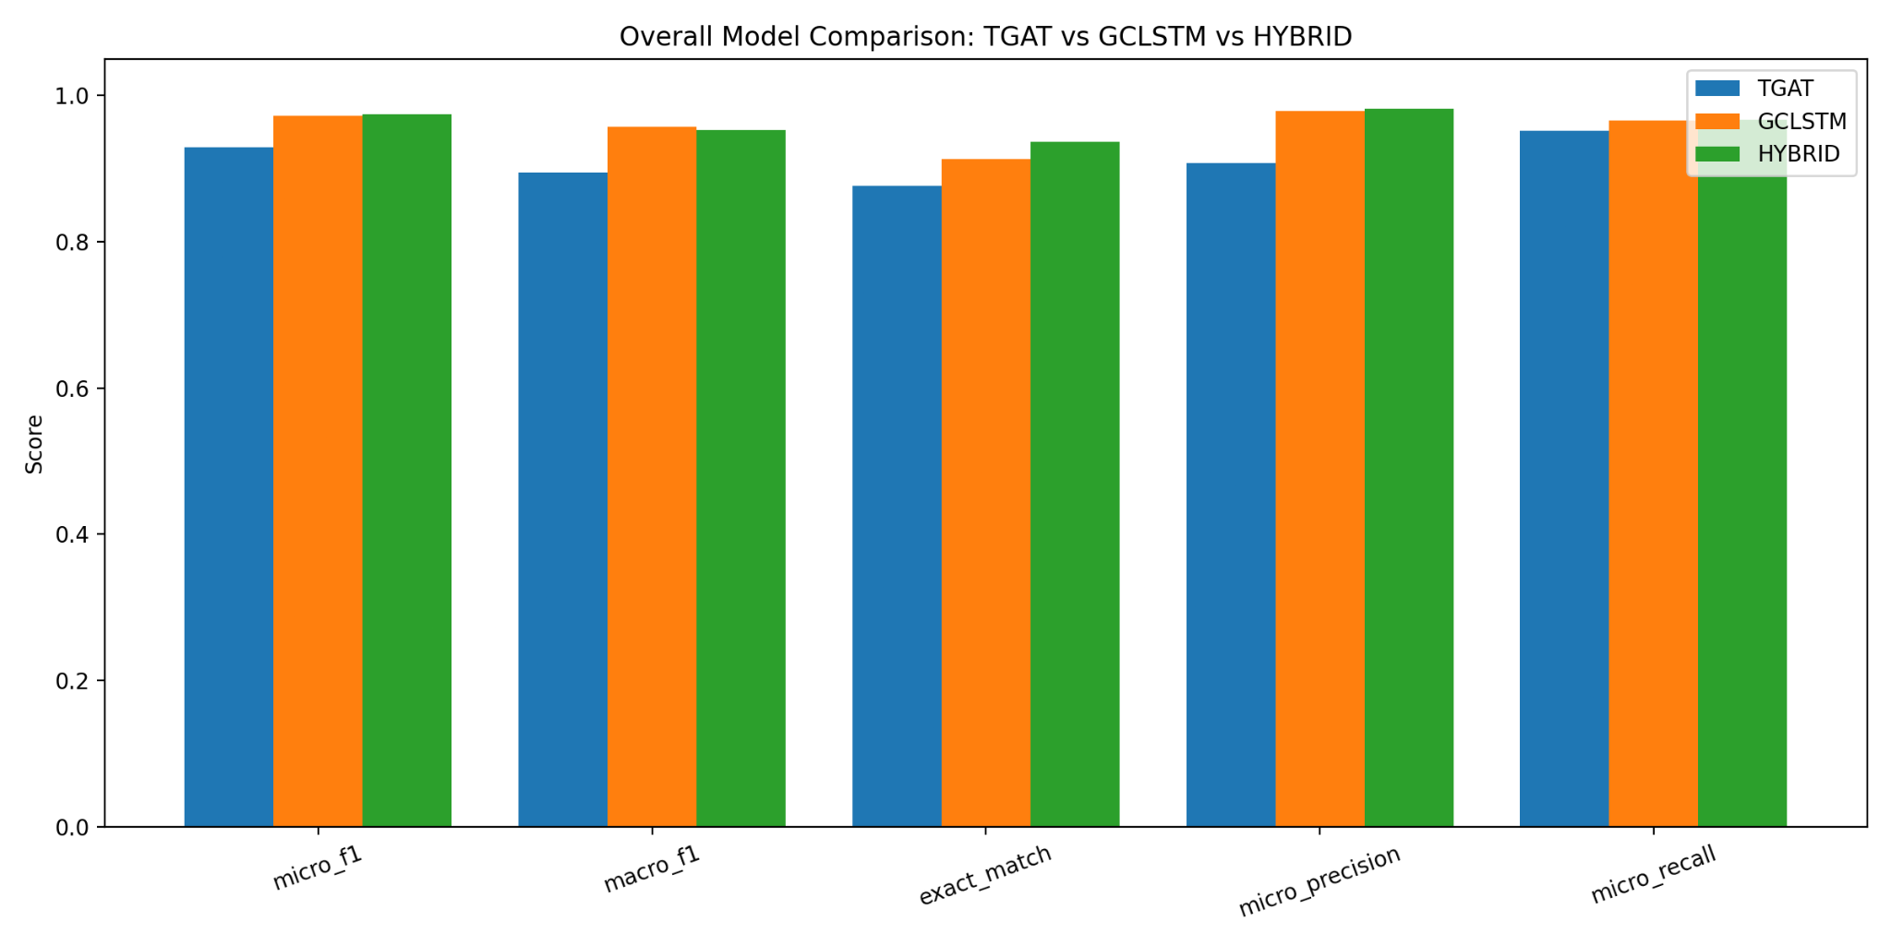
Figure 6. Overall model comparison of TGAT, GCLSTM, and Hybrid architectures.

3.2. Per-Class Performance Analysis

The per-class results provide a more detailed understanding of model behavior. Table 8 presents the F1-scores of TGAT, GCLSTM, and Hybrid models for each attack class. The results show that all three models performed strongly on high-support and structurally distinctive classes such as SSH-BRUTE-FORCE, SYN-FLOOD, DDOS-ICMP, PORT-SCANNING, and SQL-INJECTION. However, performance differences were more visible in classes such as ARP-SPOOF, FTP-BRUTE-FORCE, and XSS.

Table 8. Per-class F1-score comparison of TGAT, GCLSTM, and Hybrid models.
Class | TGAT F1 | GCLSTM F1 | Hybrid F1
ARP-SPOOF | 0.8029 | 0.9333 | 0.9258
BENIGN | 0.9496 | 0.9832 | 0.9725
DDOS-ICMP | 0.9516 | 0.9921 | 0.9895
EXPLOITING-FTP | 0.9167 | 0.9679 | 0.9283
FTP-BRUTE-FORCE | 0.8571 | 0.9357 | 0.9679
PORT-SCANNING | 0.9195 | 0.9580 | 0.9881
SQL-INJECTION | 0.9256 | 0.9776 | 0.9551
SSH-BRUTE-FORCE | 0.9780 | 0.9804 | 0.9904
SYN-FLOOD | 0.9593 | 1.0000 | 1.0000
XSS | 0.6894 | 0.8409 | 0.8099

The TGAT model achieved strong results in most classes but showed weaker performance for ARP-SPOOF and XSS. For ARP-SPOOF, TGAT achieved an F1-score of 0.8029, while GCLSTM and Hybrid achieved 0.9333 and 0.9258, respectively. For XSS, TGAT reached only 0.6894 F1-score, while GCLSTM improved this to 0.8409 and Hybrid achieved 0.8099.

GCLSTM provided the most balanced class-level performance overall. It achieved very high F1-scores in DDOS-ICMP, SQL-INJECTION, SSH-BRUTE-FORCE, and SYN-FLOOD classes. In particular, the SYN-FLOOD class reached an F1-score of 1.0000, while DDOS-ICMP reached 0.9921. This indicates that graph-based recurrent memory was effective in capturing attack patterns that evolve across consecutive time windows.

The hybrid model achieved the best F1-score in several important attack categories. It produced the highest F1-score for FTP-BRUTE-FORCE with 0.9679, PORT-SCANNING with 0.9881, SSH-BRUTE-FORCE with 0.9904, and SYN-FLOOD with 1.0000. These results support the assumption that combining temporal attention with sequential graph memory can improve the detection of attacks that involve repeated communication attempts or evolving graph patterns.

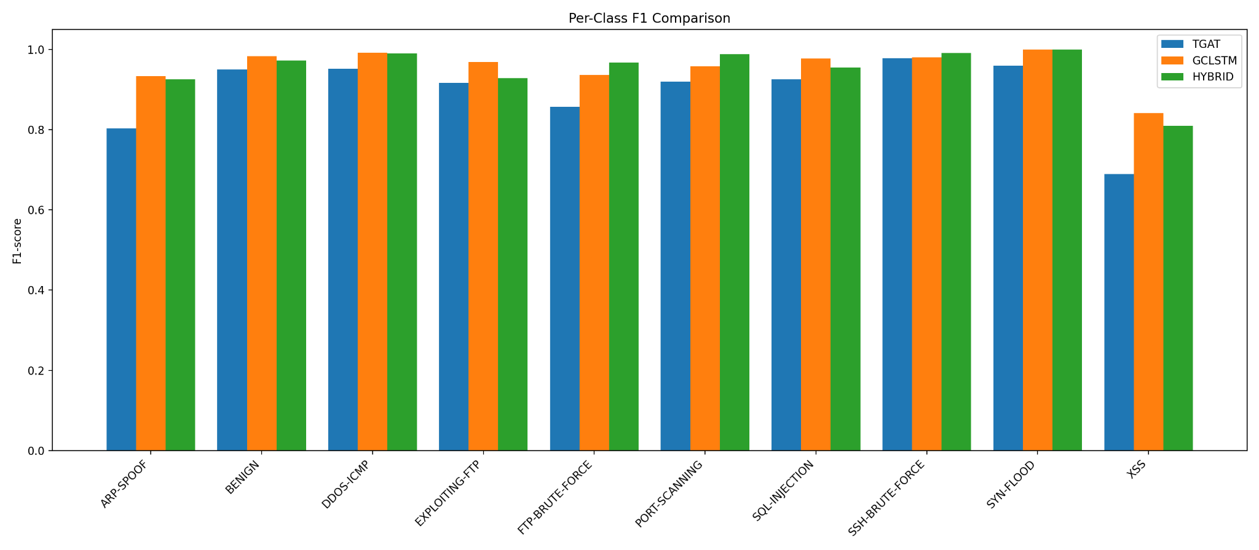
Figure 7. Per-class F1-score comparison of TGAT, GCLSTM, and Hybrid models.

3.3. Probability Distribution Analysis

The predicted probability distributions were analyzed in order to understand the confidence behavior of the models. The probability distribution plots show that GCLSTM and Hybrid models produced stronger concentration near probability values close to 1.0 for many correctly detected classes. This indicates that these models made high-confidence predictions for several attack categories. In contrast, TGAT showed a more dispersed probability behavior, which is consistent with its lower exact match and macro-F1 results.
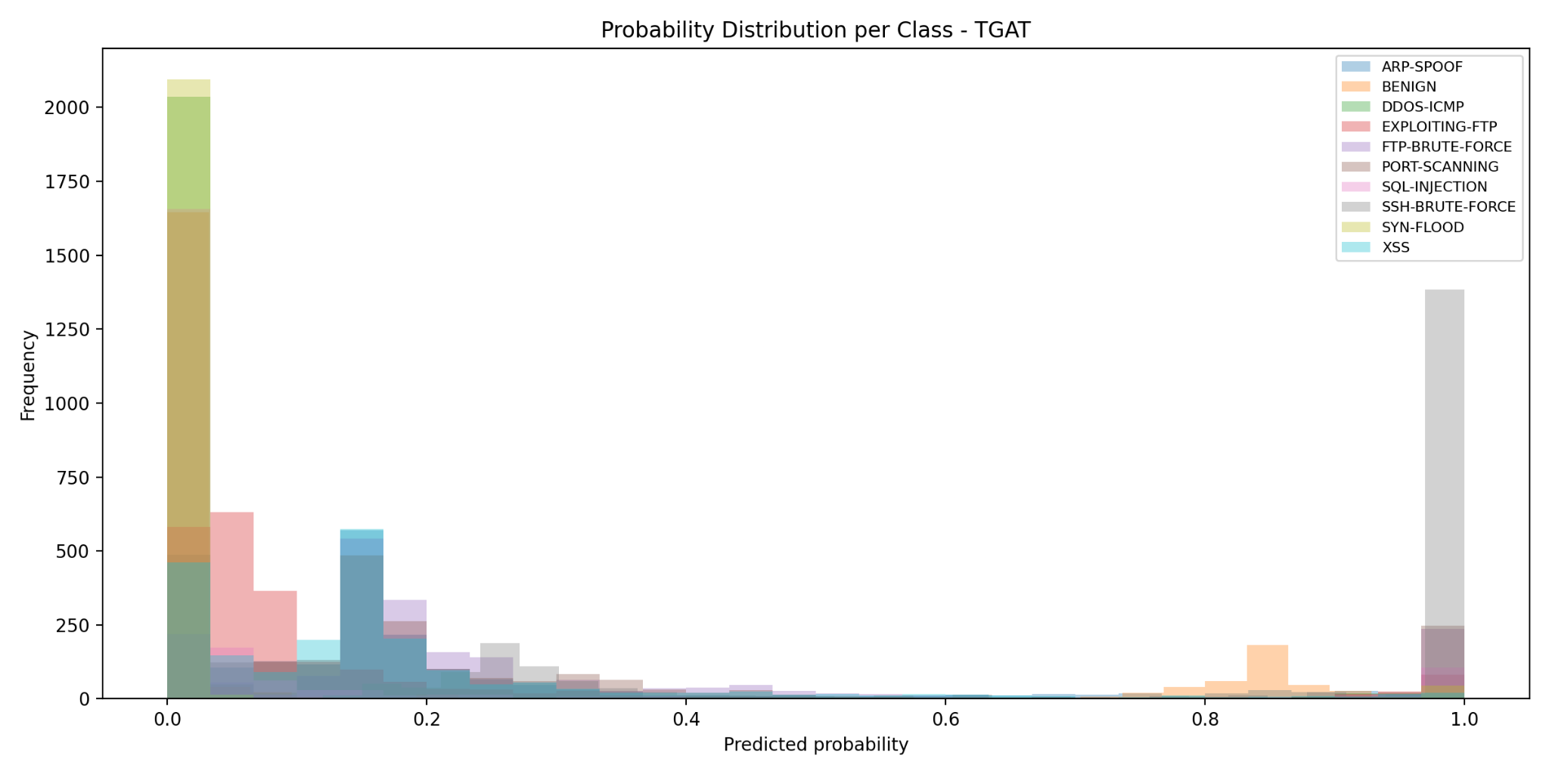
Figure 8. Probability distribution per class for the TGAT model.

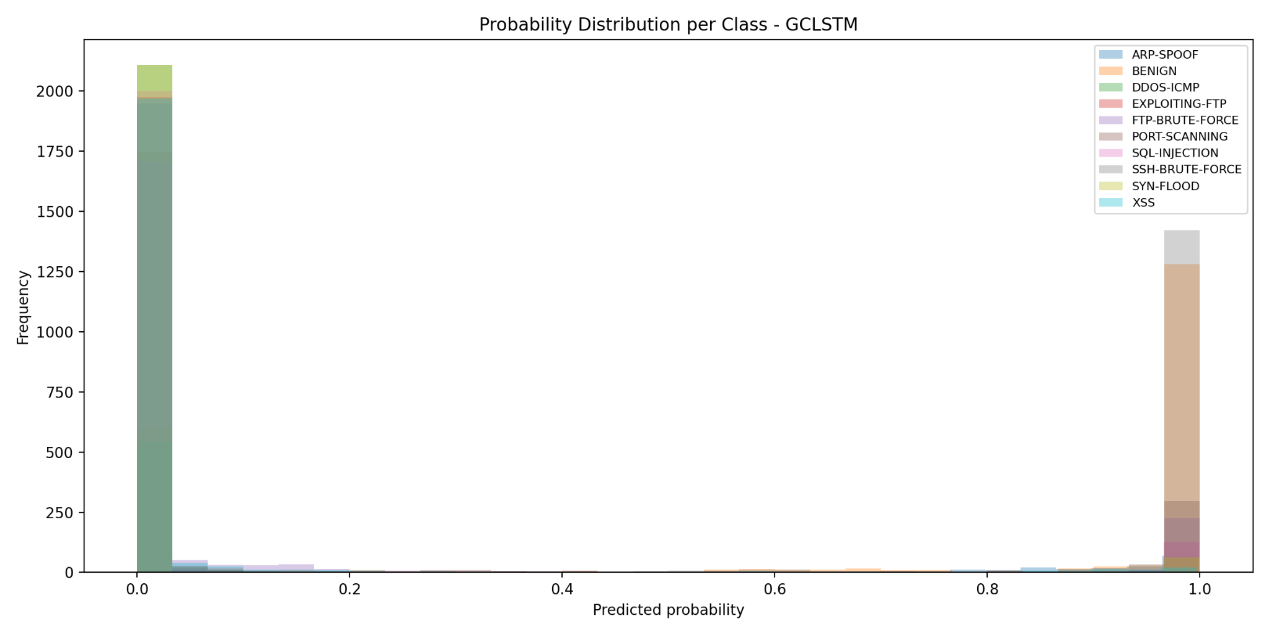
Figure 9. Probability distribution per class for the GCLSTM model.

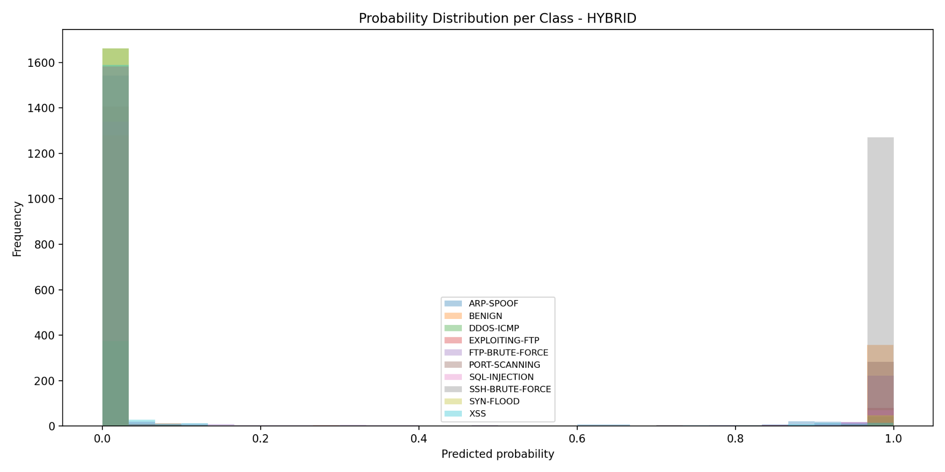
Figure 10. Probability distribution per class for the Hybrid model.

The Hybrid model showed clear high-confidence prediction behavior for dominant and structurally distinctive classes. However, probability distribution alone does not fully explain class-level performance. For example, XSS still remained one of the more challenging classes despite relatively high precision in GCLSTM and Hybrid. This suggests that the model was conservative in predicting XSS: when it predicted XSS, it was often correct, but it missed a portion of actual XSS samples.

This behavior is visible in the classification reports. For the Hybrid model, XSS precision was 0.94, while recall was 0.71. Similarly, GCLSTM achieved 0.94 precision and 0.76 recall for XSS. This indicates that XSS detection suffered more from false negatives than false positives. Therefore, future improvements should focus on increasing recall for minority or application-layer attack classes.

3.4. Error Breakdown Analysis

The multilabel error breakdown was used to examine true positives, false positives, false negatives, and true negatives for each class. These results provide insight into which classes were reliably detected and which classes caused more errors.
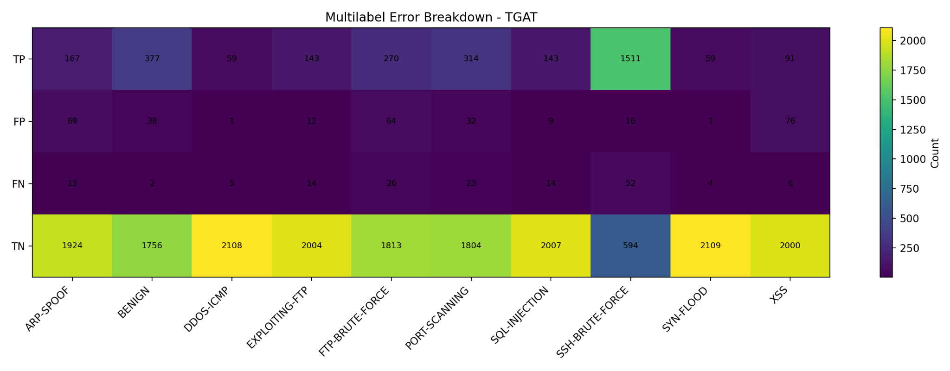
Figure 11. Multilabel error breakdown for TGAT.

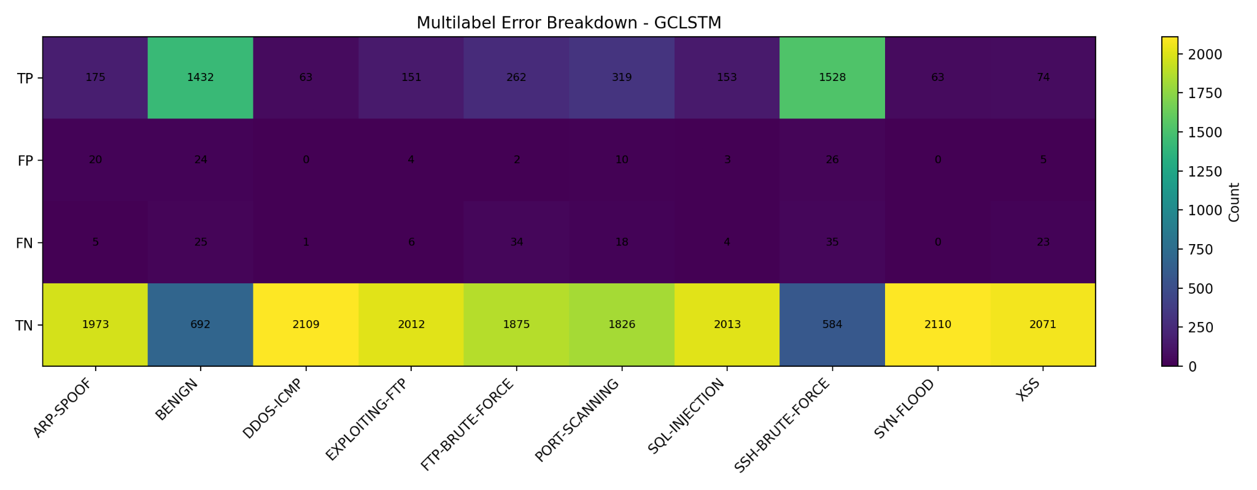
Figure 12. Multilabel error breakdown for GCLSTM.

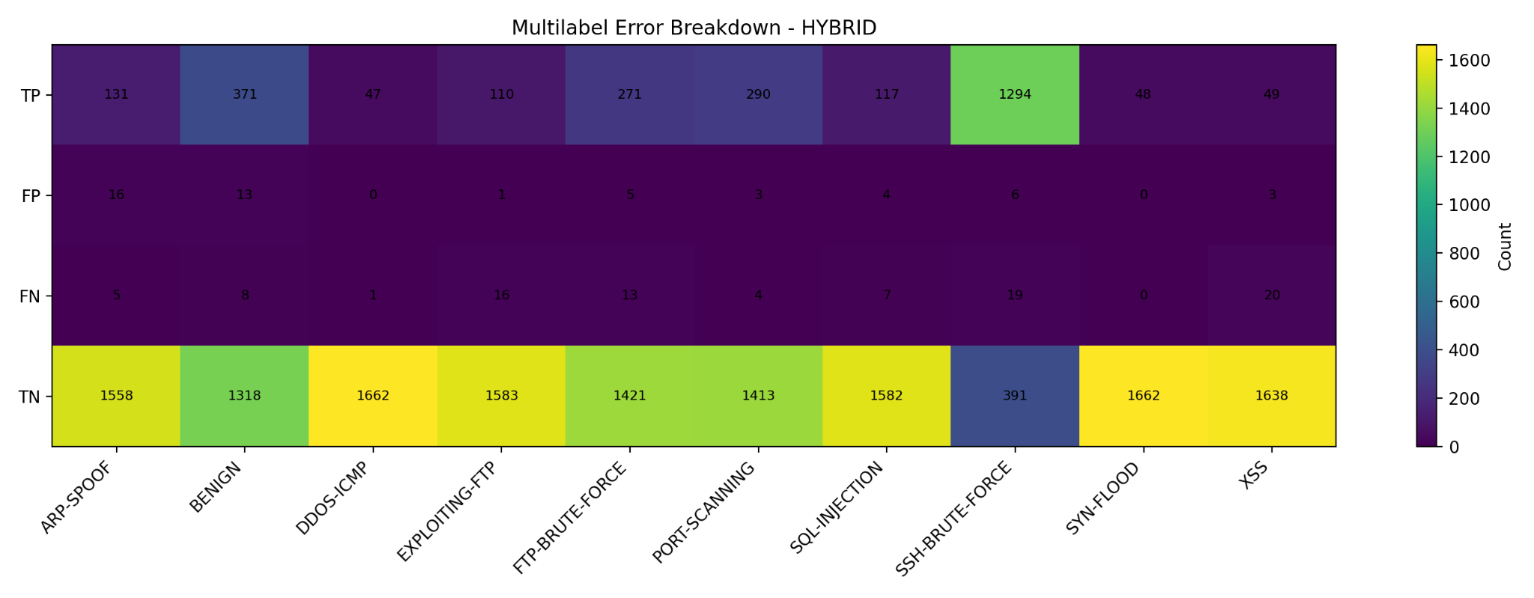
Figure 13 Multilabel error breakdown for Hybrid.

The TGAT model produced more false positives compared to the other two models. This is especially visible in classes such as ARP-SPOOF, FTP-BRUTE-FORCE, and XSS. The TGAT report shows that XSS had a precision of 0.54 and recall of 0.94, meaning that TGAT detected most XSS samples but also generated many false alarms for this class.

GCLSTM reduced false positives significantly and achieved a more stable balance between precision and recall. Its precision values were above 0.89 for all classes, and most classes exceeded 0.95 F1-score. However, XSS remained relatively weaker due to lower recall.

The Hybrid model produced the highest exact match score and the highest micro-F1 score among the three architectures. Its false positive counts were generally lower, and its class-level precision was very strong. However, the Hybrid model also showed reduced recall in XSS and EXPLOITING-FTP compared to some other classes. This indicates that the hybrid architecture was more precise but sometimes conservative for minority or application-layer attacks.

3.5. Discussion

The experimental results show that temporal graph-based learning is effective for network intrusion detection. All three models achieved strong performance, but GCLSTM and Hybrid clearly outperformed TGAT in most metrics. This result indicates that sequential memory across graph snapshots is important for modeling cyber attack behavior. While TGAT captures time-aware neighborhood interactions, GCLSTM can preserve information across consecutive graph states, which appears to be highly useful for traffic patterns that evolve over time.

The Hybrid model achieved the best overall micro-F1 and exact match scores. This suggests that combining TGAT and GCLSTM provides a stronger representation for overall prediction consistency. The exact match score is particularly important because it evaluates whether the complete predicted label set matches the true label set. The Hybrid model’s exact match score of 0.9368 indicates that it produced more complete and consistent predictions than TGAT and GCLSTM.

However, the GCLSTM model achieved the highest macro-F1 score. Since macro-F1 gives equal weight to each class, this result shows that GCLSTM was slightly more balanced across all attack categories. The difference between GCLSTM and Hybrid macro-F1 scores was small, but it is still meaningful. It suggests that the hybrid model improved overall prediction consistency, while GCLSTM maintained slightly better class-balanced performance.

The results also show that not all attack classes have the same level of difficulty. Classes such as SYN-FLOOD, SSH-BRUTE-FORCE, DDOS-ICMP, and PORT-SCANNING were detected with very high F1-scores. These attacks usually produce more distinctive temporal or structural patterns in network traffic. In contrast, XSS was the most challenging class for all models. This can be explained by the fact that XSS traffic may be more similar to benign web requests and may not always produce strong graph-level structural differences.

Another important observation is the effect of class support. The test set distribution shows that SSH-BRUTE-FORCE had a much larger number of positive samples than several other classes, while classes such as DDOS-ICMP, SYN-FLOOD, and XSS had lower support. Lower-support classes are more difficult to learn and evaluate reliably. This explains why macro-F1 and per-class analysis are more informative than accuracy alone in this study.

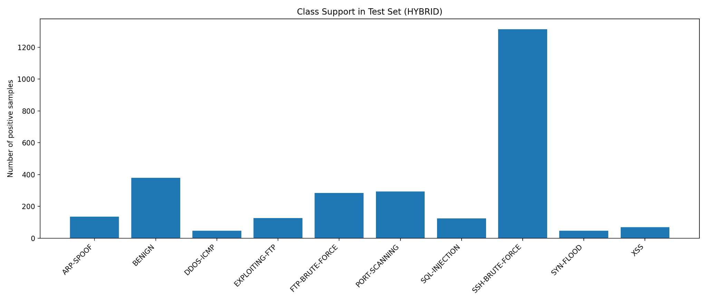
Figure 14. Class support distribution in the test set.

Overall, the results support the main motivation of this thesis. Modeling network traffic as a temporal graph allows the system to capture not only individual traffic features but also the evolving relationships between network entities. The strong performance of GCLSTM and Hybrid models shows that temporal dependencies are important for detecting slow-burn and multi-step cyber attacks. At the same time, the class-level results indicate that further improvement is still needed for application-layer and low-support attack classes such as XSS.

3.6. Limitations

Although the obtained results are promising, several limitations should be considered. First, the experiments were performed on selected classes from the LSNM2024 dataset. Therefore, the performance may change when the system is tested on different datasets, live traffic, or previously unseen attack types. Second, class imbalance still affected the difficulty of detecting certain classes, especially XSS. Although SMOTE and class-weighted learning were used, minority and application-layer attack classes remained more challenging.

Third, the current evaluation mainly focuses on classification performance and model-level comparison. Edge deployment was considered in the system design, but detailed Raspberry Pi latency, throughput, and memory measurements should be further expanded in future experiments. Finally, the system was evaluated in a controlled environment. Before real-world use, it should be tested with live network traffic and integrated with firewall or IDS platforms such as pfSense or Suricata.

4. CONCLUSIONS

This thesis presented an edge-aware temporal intrusion detection system based on Temporal Graph Neural Networks. The main objective was to detect cyber attacks in network traffic by modeling both structural relationships and temporal behavior. Instead of processing network flows as independent records, the study represented traffic as temporal graph sequences and evaluated TGAT, GCLSTM, and a hybrid TGAT–GCLSTM architecture.

The experimental results demonstrated that temporal graph-based models are effective for multiclass cyber attack detection. TGAT achieved strong results in several classes, but it remained weaker than the other models in overall performance. GCLSTM improved the results significantly by using recurrent memory across graph snapshots and achieved the highest macro-F1 score. The Hybrid TGAT–GCLSTM model achieved the highest micro-F1 score and exact match score, showing that the combination of temporal attention and sequential graph learning improves overall prediction consistency.

Class-level analysis showed that attacks such as SYN-FLOOD, SSH-BRUTE-FORCE, DDOS-ICMP, PORT-SCANNING, and FTP-BRUTE-FORCE were detected with high F1-scores. These results indicate that the proposed temporal graph representation is effective for attacks with clear structural or repeated temporal patterns. However, XSS remained the most difficult class because its behavior can be closer to benign web traffic and its support in the test set was relatively limited.

The study contributes to the fields of intrusion detection, graph-based machine learning, and edge computing. It shows that Temporal Graph Neural Networks can be adapted to cybersecurity tasks and that hybrid temporal graph architectures can provide strong detection performance. The system also provides a prototype basis for a low-cost intelligent security module that can be deployed on edge devices such as Raspberry Pi 5 and later integrated with firewall or IDS platforms.

Future work should focus on three directions. First, the system should be evaluated with additional datasets and live network traffic to measure generalization capability. Second, application-layer attacks such as XSS and SQL Injection should be improved through richer feature extraction and class-specific optimization. Third, the Raspberry Pi deployment should be further optimized and tested using detailed latency, throughput, memory, and power-consumption measurements. With these improvements, the proposed system can be extended toward a scalable and practical edge-based intrusion detection solution for institutional networks.
REFERENCES
Al-Haija, Q. A., Masoud, Z., Yasin, A., Alesawi, K., & Alkarnawi, Y. (2024a). Revolutionizing threat hunting in communication networks: Introducing a cutting-edge large-scale multiclass dataset. In 2024 15th International Conference on Information and Communication Systems (ICICS) (pp. 1–5). IEEE.
Al-Haija, Q. A., Masoud, Z., Yasin, A., Alesawi, K., & Alkarnawi, Y. (2024b). Large-Scale Network Cyberattacks Multiclass Dataset 2024 (LSNM2024). Mendeley Data, V1. https://doi.org/10.17632/7pzyfvv9jn.1
Al-Haija, Q. A., Masoud, Z., Yasin, A., Alesawi, K., & Alkarnawi, Y. (2025). End-to-end threat hunting with a novel multiclass dataset for intelligent intrusion detection. Authorea Preprints.
Bharathi, P. S., & Raj, M. M. (2025). Graph neural networks for intrusion detection in next-generation 6G networks: A cybersecurity perspective. In 2025 6th International Conference on Intelligent Communication Technologies and Virtual Mobile Networks (ICICV) (pp. 1306–1312). IEEE.
Birleşmiş Milletler Kalkınma Programı. (2025). Sürdürülebilir Kalkınma Amaçları. United Nations Development Programme Türkiye. https://turkiye.un.org/tr/sdgs. Son erişim tarihi: 11 Kasım 2025.
Chawla, N. V., Bowyer, K. W., Hall, L. O., & Kegelmeyer, W. P. (2002). SMOTE: Synthetic minority over-sampling technique. Journal of Artificial Intelligence Research, 16, 321–357.
Cobos, E. V., Cakir, S., Straub, S., Qiang, C. Z., & Torgusson, C. (2024). A review of the economic costs of cyber incidents. Washington, DC: World Bank.
Dai, C., Tang, Q., & Ding, H. (2024). TGAT: Temporal graph attention network for blockchain phishing scams detection. In 2024 International Conference on Computer, Information and Telecommunication Systems (CITS) (pp. 1–7). IEEE.
IBM. (2024). Escalating data breach disruption pushes costs to new highs. IBM Newsroom. https://newsroom.ibm.com/2024-07-30-ibm-report-escalating-data-breach-disruption-pushes-costs-to-new-highs. Son erişim tarihi: 15 Kasım 2025.
Ibrahim, A. S. T., Paolini, E., Cugini, F., & Paolucci, F. (2025). Real-time graph neural network for malicious traffic detection. In 2025 IEEE International Conference on Machine Learning for Communication and Networking (ICMLCN)(pp. 1–6). IEEE.
Khraisat, A., Gondal, I., Vamplew, P., & Kamruzzaman, J. (2019). Survey of intrusion detection systems: Techniques, datasets and challenges. Cybersecurity, 2(1), 1–22.
Kipf, T. N., & Welling, M. (2016). Semi-supervised classification with graph convolutional networks. arXiv preprint arXiv:1609.02907.
Kose, H. T., Nunez-Yanez, J., Piechocki, R., & Pope, J. (2024). A survey of computationally efficient graph neural networks for reconfigurable systems. Information, 15(7), 377.
Pareja, A., Domeniconi, G., Chen, J., Ma, T., Suzumura, T., Kanezashi, H., Kaler, T., Schardl, T., & Leiserson, C. (2020). EvolveGCN: Evolving graph convolutional networks for dynamic graphs. In Proceedings of the AAAI Conference on Artificial Intelligence, 34(04), 5363–5370.
Ring, M., Wunderlich, S., Scheuring, D., Landes, D., & Hotho, A. (2019). A survey of network-based intrusion detection data sets. Computers & Security, 86, 147–167.
Rossi, E., Chamberlain, B., Frasca, F., Eynard, D., Monti, F., & Bronstein, M. (2020). Temporal graph networks for deep learning on dynamic graphs. arXiv preprint arXiv:2006.10637.
Sankar, A., Wu, Y., Gou, L., Zhang, W., & Yang, H. (2020). DySAT: Deep neural representation learning on dynamic graphs via self-attention networks. In Proceedings of the 13th International Conference on Web Search and Data Mining(pp. 519–527).
Seo, Y., Defferrard, M., Vandergheynst, P., & Bresson, X. (2018). Structured sequence modeling with graph convolutional recurrent networks. In International Conference on Neural Information Processing (pp. 362–373). Springer.
Söhner, E., Helm, M., & Jaeger, B. (2020). Temporal Graph Neural Networks. Technical University of Munich, Chair of Network Architectures and Services.
T.C. Cumhurbaşkanlığı Strateji ve Bütçe Başkanlığı. (2023). 12. Kalkınma Planı (2024–2028). Ankara: CSBB. https://www.sbb.gov.tr/wp-content/uploads/2023/12/On-Ikinci-Kalkinma-Plani_2024-2028_11122023.pdf. Son erişim tarihi: 11 Kasım 2025.
T.C. Sanayi ve Teknoloji Bakanlığı. (2025a). 2030 Sanayi ve Teknoloji Stratejisi. Ankara. https://www.sanayi.gov.tr/plan-program-raporlar-ve-yayinlar/strateji-belgeleri/mu2103011621. Son erişim tarihi: 11 Kasım 2025.
T.C. Sanayi ve Teknoloji Bakanlığı. (2025b). 2030 Sanayi ve Teknoloji Stratejisi: Öncelikli program ve projeler. Anahtar Dergisi, 37(436), 15–25. https://edergi.sanayi.gov.tr/File/Journal/2025/4/4_2025.pdf. Son erişim tarihi: 11 Kasım 2025.
T.C. Sanayi ve Teknoloji Bakanlığı. (2025c). Geleceğin Yapay Zeka Teknolojileri (GYZT) Odak Teknoloji Ağı (OTAĞ): OTAĞ Sonuç Raporu. Ankara. https://arge.ssb.gov.tr/TeknolojiYolHaritalari/PublishingImages/Sayfalar/GYZT%20OTA%C4%9E/GYZT_OTAG_Sonuc_Raporu.pdf. Son erişim tarihi: 11 Kasım 2025.
Tailor, S. A., Fernandez-Marques, J., & Lane, N. D. (2020). Degree-quant: Quantization-aware training for graph neural networks. arXiv preprint arXiv:2008.05000.
Xu, D., Ruan, C., Korpeoglu, E., Kumar, S., & Achan, K. (2020). Inductive representation learning on temporal graphs. arXiv preprint arXiv:2002.07962.

